Group and Squadron Logos

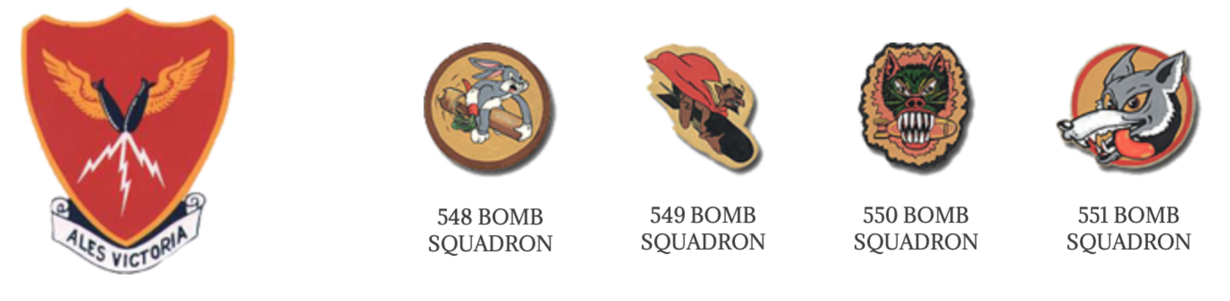
All members of the 385th Bomb Group and the 548th, 549th, 550th and 551st Squadrons are familiar with the unit logos or patches. The group logo was a Shield with crossed lightening daggers and the Motto “Ales Victoria”. The Squadrons' were a Rabbit carrying a Bomb (548th), a Devil riding a Bomb (549th), a Panther with Bomb in its mouth (550th), and a Wolf head (551st). The majority of us had one of these logos sewn on our jackets to show our proud group or squadron heritage. A flag which depicts these logos was designed and made by our Past President, Col. Leo LaCasse. He presented this 385th Bomb Group flag to Col. Jim McDonald at the 19th Annual Re­ union in Hampton, VA. The flag is now in safe keeping and in the fu­ ture it will proudly be displayed at all 385th Bomb Group Memorial Association functions.
Some time ago, Bill Varnedoe received a picture of a Porcupine carrying a bomb. A memo included with the picture claimed that this was the official logo of the 550th Bomb Squadron. Bill undertook an extensive search to obtain the truth about the 550th Squadron logo. Ed Stern, the 350th Executive Officer, said that he only knew of the Panther logo. However Bill received the following letter from Ray Borman, an English author of several Eighth Air Force books:

"A great many of the emblems taken up by the units of the USAAF during WWII were in fact 'unofficial' insignia which were never ever approved by the USAAF Heraldic Section who were supposed to assess each design and accredit them with the official seal of approval. The war produced such a vast number of insignia in a short time that they never could deal with them all—or anywhere near them all.
The shield emblem used for the 385th Bomb Group as
a whole was in fact never officially granted approval. The emblem for the 548th Sqn. was initially approved as a B-17 with a lightning strike and this was replaced by an approved emblem of Bugs Bunny riding a bomb (not sure when). The 549th Sqn’s. emblem of the Devil riding a bomb was never approved officially but was in use throughout the war. The 550th Sqn’s. insignia is an unusual case. Its emblem of the Panther biting a bomb was never officially approved, but curiously it actually replaced, as a result of common usage, the officially approved motif of a Porcupine carrying a bomb—this happened sometime during 1943. Perhaps the Porcupine was not considered to be aggressive enough(?)
Finally, the 551st Sqn’s Wolf head was an officially approved insignia.
We never stop finding in­teresting facets in our search to record history. As always, one is left with the burning question: how the squadron CO did not know of the offiicial approved insignia? Maybe he did and just took a dislike to it. Maybe a revised design was submitted to the Heraldic Section but just got stuck n the pipeline. The new panther head logo must have been used with (at least) local official approval. But Gt. Ashfield was a long way from Washington when it came to such things....”

In an inquiry to the Department of the Army, The Institute of Heraldry, Bill received a letter signed by the Chief, Heraldic Services and Support Division, dated December 31, 2003. In the letter they categorically state that the 385th Bomb Group, the 548th Bomb Squadron, the 549th Bomb Squadron, the 550th Bomb Squadron and the 551st Bomb Squadron had no approved logos during World War II. Later, after the war, the 549th, 550th and 551st Bomb Squadrons were re­activated as Atlas Missile Squadrons and received approved logos. These logos did not resemble any of the logos of the Bomb Squadrons.

